Central University of Tamil Nadu, Thiruvarur  UGC-NET Coaching Centre for SC/ST/OBC  (Non- Creamy Layer) & Minorities | 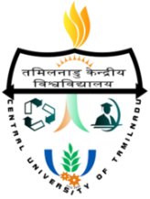  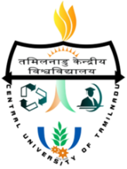

Affix a recent
Passport size
Photograph here

APPLICATION FORM

1. Name in full  (In block letters)  Father's/Husband's Name |  | :  :  : | Mr./Ms.
2. Sex: |  | 3.Nationality: |  |  |  |  |  |  |  |  |  |  |  |  | 4. Marital Status:
5. Address  (to which communication  should be sent)  Telephone & E-mail |  | :
6. Date of Birth |  | :
 |  |  |  | Day |  |  |  | Month |  |  |  |  | Year
7. Place of Birth |  | :
 |  | : |  |  |  |  |  |  |  | District |  |  |  |  |  |  |  |  |  | State
- Are you a member of  OBC/SC/ST/Minority? |  | : | OBC |  |  |  |  |  | SC |  |  |  | ST |  |  |  | Minority
 |  | (Please attach Certificate from the Competent Authority. In case of OBC candidates, valid non-creamy layer certificate issued in the last financial year should be attached).
- Have you applied for  UGC-NET Exam (or)  Other Competitive Exam  (Please Specify) |  | : |  | Yes |  |  |  |  |  |  | No |  |  |  |  |  |  |  | Others

DECLARATION BY THE APPLICANT

I hereby declare that all statements made in this application are true, complete and correct to the best of my knowledge and belief

Place:
Date:
Signature of the Applicant

