Registration Form
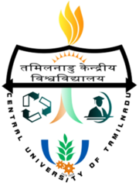
NAAC & CUTN Sponsored
Two Days National Workshop on
“Quality Assurance and Sustenance: Need for Strategic Planning”
January 5 & 6, 2018
Organized by
IQAC, Central University of Tamil Nadu

Name (in Capital Letters) :------------------------------------------------
Designation : ------------------------------------------------
Name of the Institution : -------------------------------------------------
Address :-------------------------------------------------
--------------------------------------------------
--------------------------------------------------
Mobile Number : --------------------------------------------------
E mail ID : --------------------------------------------------
IQAC Coordinator : YES / NO
NIRF Nodal officer : YES / NO
Others (Specify) :
Accommodation required : YES / NO
Arrival Date : ----------------------------------------------------

Signature : ----------------------------------------------------

